“An INtegrated next generation PREParedness programme
for improving effective inter-organisational response capacity
in complex environments of disasters and causes of crises”

D4.2 Scenario Builder

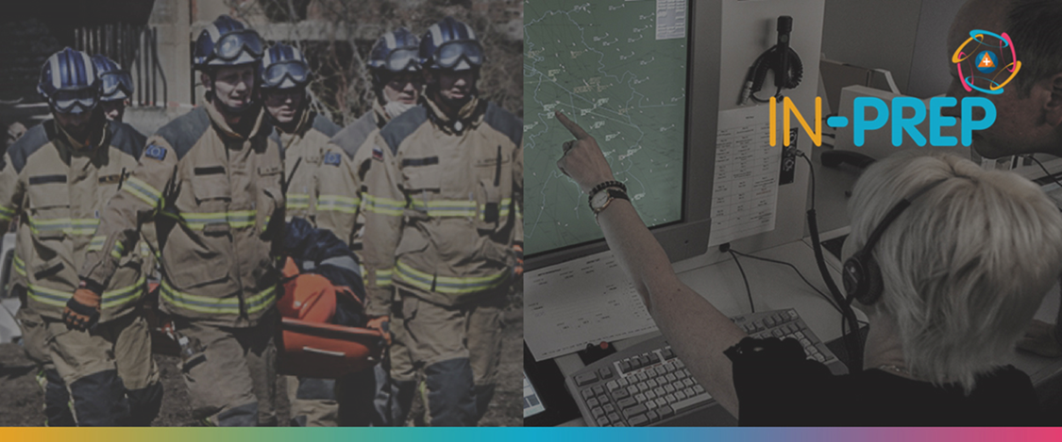

Document Summary Information

Grant Agreement No | 740627 | Acronym | IN-PREP
Full Title | An Integrated next generation preparedness programme for improving effective interorganisational response capacity in complex environments of disasters and causes of crises
Start Date | 01/09/ 2017 | Duration | 36 months
Project URL | https://www.in-prep.eu/
Deliverable | D4.2 - Scenario builder
Work Package | WP4 - IN-PREP Scenario Building
Contractual due date | 31.12.2018 | Actual submission date |  | 02.04.2019
Nature | Other | Dissemination Level |  | Confidential
Lead Beneficiary | EXUS
Responsible Author | Alexandros Karalis (EXUS), Spyros Evangelatos (EXUS)
Contributions from | Leonidas Perlepes (STWS), Guillaume Inglese (DXT)

Executive Summary
According to the International Red Cross, disaster preparedness refers to measures taken to prepare for and reduce the consequences and effects of disasters, either natural or man-made. In order to be prepared for such disasters, a training tool is necessary not only for improving the technical skills of the involved people (agencies, volunteers, etc.) but also for coordination and management purposes between them.
For the purpose of training into preparedness actions (i.e. hazards and incidents), a realistic scenario script is created based on historical or fictitious events, through an easy-to-use, software-based tool where one, having the role of the trainer, can create a storyline that fully describes the disaster phenomena. This tool provides some basic functionalities, such as the creation and modification of a scenario script but also the data exchange with other tools, including third party and legacy systems. The nature of data can vary, from information regarding the event (quantitative or qualitative) and meteorological data to information about resources and mitigation actions. All the available information can be visualized in different systems and conveyed in different tools for impact assessment. All the above-mentioned features and functionalities are included in the Scenario Building Tool, which has been created for the IN-PREP project.
Copyright message
©IN-PREP Consortium, 2017-2020. This deliverable contains original unpublished work except where clearly indicated otherwise. Acknowledgement of previously published material and of the work of others has been made through appropriate citation, quotation or both. Reproduction is authorised provided the source is acknowledged.

https://media.ifrc.org/ifrc/what-we-do/disaster-and-crisis-management/disaster-preparedness/

