

**“An INtegrated next generation PREParedness programme**

**for improving effective inter-organisational response capacity**

**in complex environments of disasters and causes of crises”**

**D4.1 Scenario tool design**

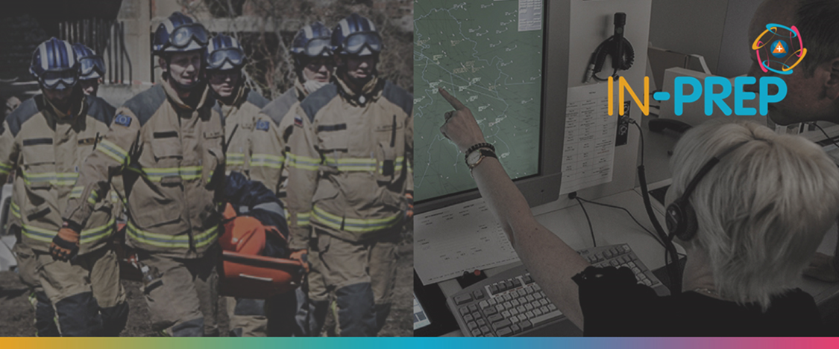

Document Summary Information

|  |  |  |  |  |
| --- | --- | --- | --- | --- |
| **Grant Agreement No** | 740627 | **Acronym** | IN-PREP | |
| **Full Title** | An Integrated next generation preparedness programme for improving effective interorganisational response capacity in complex environments of disasters and causes of crises | | | |
| **Start Date** | 01/09/ 2017 | **Duration** | 36 months | |
| **Project URL** | <https://www.in-prep.eu/> | | | |
| **Deliverable** | D4.1 - Scenario tool design | | | |
| **Work Package** | WP4 - IN-PREP Scenario Building | | | |
| **Contractual due date** | 08.03.2019 (revision) | **Actual submission date** | | 11.03.2019 (revision) |
| **Nature** | R (Report) | **Dissemination Level** | | CO (Confidential) |
| **Lead Beneficiary** | STWS | | | |
| **Responsible Author(s)** | Leonidas Perlepes (STWS), Antonis Kostaridis (STWS), Aggelos Aggelis (STWS), Lefteris Voumvourakis (STWS) | | | |
| **Contributions from** | Panagiotis Efthimiou (EXUS), Lavinia Cadar (CPLAN), Marcello Marzoli (CNVVF), Pia Nottebaum (DHPol), Cian O'Brien (HSE), Mark Roberts (PSNI), Luis Sousa (AIR), Grigoleit Sonja (FhG), Romain Charbit (DXT), Lazaros Filippidis (UoG), Fabrizio Ferrucci (IESC), Rozemarijn Veneman (SRIJ), Fay Misichroni (ICCS), Evangelos Sdongos (ICCS) | | | |

**Executive Summary**

Natural and manmade disasters are becoming more frequent, increasing in severity and affecting more people than ever before. The reasons vary but include climate change, population growth and urbanisation. As such, developing the tools, processes and best practices to tackle with natural and manmade disasters more effectively has become an urgent priority around the globe. To do so, disaster managers or responders require adequate technology, tools and practices aiding them to systematically manage heterogeneous information from various sources and efficiently collaborate for effectively assisting those in need.

Prior to civil protection organisations improving their crisis management capabilities with new tools and services they must obtain a clear idea of the problems they are trying to solve and as such upgrade their processes and practises. The project acknowledges the challenges for transboundary collaboration in response planning, efficient resource management and most importantly lack of interoperability in regards to data sharing and connecting people and diverse processes.

Before responding effectively, crisis managers and actors across chain of command must be prepared. To do so, collaborative response planning and realistic training are powerful tools for improving understanding and enhancing synergies to cope with the unexpected. In this direction, IN-PREP equips the civil protection agencies with integrated tools and services to support transboundary crisis management, systematic training and to interlink a wide range of stakeholders strengthening transboundary collaboration.

The work presented in this document addresses a core component to the above scope, namely the Scenario Building Tools. It is a suite of tools built around scenario editing and execution capabilities to allow civil protection actors of all disciplines to create multiple hazard scenarios and as such enhance their training boosting realism and collaboration. The Scenario Building Tool is operated by Trainers or Crisis Managers that need no more to rely on static scenarios as the tool allows dynamic design and iteration of training sessions in real-time. In addition, the tool interconnects with modelling and simulation platforms facilitating as such freedom with respect to scenario variables. The scenario script is digitised and can be adapted, re-played and evaluated. Furthermore, the script is loaded and executed to the IN-PREP Training Platform and the Command, Control and Coordination Systems shared instantly with the Trainees, the later experiencing an improved training session which according to the script timeline expects for their response actions.

***Copyright message***

©IN-PREP Consortium, 2017-2020. This deliverable contains original unpublished work except where clearly indicated otherwise. Acknowledgement of previously published material and of the work of others has been made through appropriate citation, quotation or both. Reproduction is authorised provided the source is acknowledged.