“An INtegrated next generation PREParedness programme
for improving effective inter-organisational response capacity
in complex environments of disasters and causes of crises”

D3.5 Preparedness Platform and IN-PREP layers for response planning and scenario editing (Iteration One)

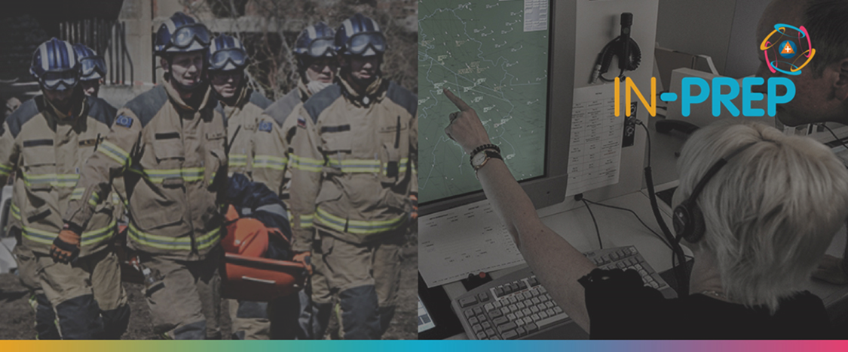

Document Summary Information

Grant Agreement No | 740627 | Acronym | IN-PREP
Full Title | An Integrated next generation preparedness programme for improving effective interorganisational response capacity in complex environments of disasters and causes of crises
Start Date | 01/09/ 2017 | Duration | 36 months
Project URL | https://www.in-prep.eu/
Deliverable | D3.5 Preparedness Platform and IN-PREP layers for response planning and scenario editing (Iteration One)
Work Package | WP3- IN-PREP System Design
Contractual due date | 28.02.2019 | Actual submission date |  | 11.04.2019
Nature | Report (R) | Dissemination Level |  | Confidential (CO)
Lead Beneficiary | DXT
Responsible Author | Guillaume INGLESE (DXT)
Contributions from | Fabrizio FERRUCCI (IESC), Lazaros FILIPPIDIS (UoG), Alexandros KARALIS (EXUS), Fay MISICHRONI (ICCS), Leonidas PERLEPES (STWS), Gunnar SCHWOCH (DLR), Evangelos SDONGOS (ICCS), Luis SOUSA (AIR), Angelos STAMOU (ICCS)

Executive Summary

This deliverable deals with the training tools, the training processes and the involved layers of information provided by the IN-PREP platform. The goal of the IN-PREP preparedness platform is to facilitate and improve preparation for transboundary crisis management by providing tools to:
- create plausible crisis scenarios, supported by modelling tools, which will be executed in training sessions,
- digitalize and share collaborative response plans that will be tested along the scenario execution,
- manage training sessions that follow trainees’ actions and allow them to visualize and assess the situation using real and simulated information from various systems, as well as to follow established collaborative plans.

The IN-PREP training platform will be built around the CRIMSON platform and will benefit from its:
- interoperability capabilities to access information and tools from the other IN-PREP systems like Building Tool,
- sharing and filtering capabilities to add the multi-user and collaborative dimension to the training,
- situational awareness capabilities to provide trainees with real-time information.
A training session will rely on facts, empirical data, simulations and live data, provided by heterogeneous systems, to help creating accurate, meaningful and true to scale situations for adequate planning and training. These various source of information are modelling tools, simulation tools, Command & Control systems (C2) and the scenario builder (SB).

The design work was based on the outcome of the WP2, on discussions with project partners in the scope of WP3, and the first TTX results. Within this document we present the first version of this design; it will be revised M31 in the second version of the document.
Copyright message
©IN-PREP Consortium, 2017-2020. This deliverable contains original unpublished work except where clearly indicated otherwise. Acknowledgement of previously published material and of the work of others has been made through appropriate citation, quotation or both. Reproduction is authorised provided the source is acknowledged.

