“An INtegrated next generation PREParedness programme
for improving effective inter-organisational response capacity
in complex environments of disasters and causes of crises”

D3.3 C2 Definitions and function
(Iteration One)

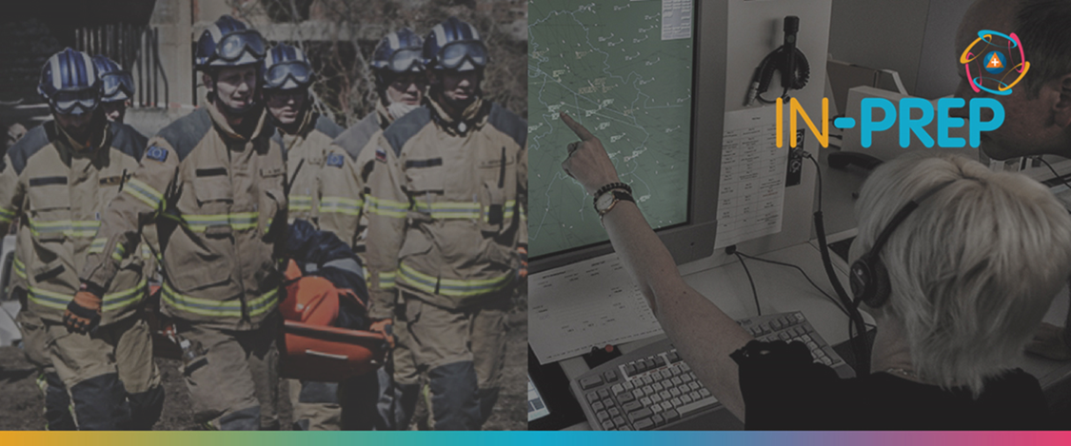

Document Summary Information

Grant Agreement No | 740627 | Acronym | IN-PREP
Full Title | An Integrated next generation preparedness programme for improving effective interorganisational response capacity in complex environments of disasters and causes of crises
Start Date | 01/09/ 2017 | Duration | 36 months
Project URL | https://www.in-prep.eu/
Deliverable | D3.3 - C2 Definitions and function V1
Work Package | WP3 - IN-PREP System Design
Contractual due date | 28.02.2019 | Actual submission date |  | 11.04.2019
Nature | Report (R) | Dissemination Level |  | Confidential (CO)
Lead Beneficiary | STWS
Responsible Author | Leonidas Perlepes (STWS), Antonis Kostaridis (STWS), Lefteris Voumvourakis (STWS), Aggelos Aggelis (STWS),
Contributions from | Marcello Marzoli (CNVVF), Holger Bracker (ADS), Willem Treurniet (SRIJ), Gerwin de Groot (SRIJ), Fay Misichroni (ICCS), Evangelos Sdongos (ICCS)

Executive Summary
Nowadays, public and private safety agencies, such as civil protection, police and fire brigade agencies, base the management of emergency situations they respond to on sophisticated software tools that provide “command” and “control” actions. These software tools are known as Command & Control Systems (C2). C2 systems support civil protection agencies’ critical operations that are related to preparedness, mitigation, response and recovery phase of the disaster lifecycle. Using C2 systems, agencies are able to execute a set of operations (such as organizing preparedness operations, analyzing emergency situations, managing emergency response in order to facilitate incident response and communication in the field, etc.), in an efficient and effective way.
However, the existence of emergency situations that spread across borders, requires the involvement of different civil protection agencies, often with different C2 systems. Communication and organization issues between involved agencies usually has a negative impact on the emergency response effectiveness. The IN-PREP project aims to increase interoperability between different agencies and C2 systems by providing a collaborative platform that puts emphasis mainly on the Preparedness phase and then on the Response phase of the Crisis Management cycle.
Deliverable D3.3 presents the design principals and capabilities of a typical C2 system. Moreover, the encapsulation of C2 functionalities by the IN-PREP platform and the added valued these functionalities add to the IN-PREP platform are presented.
Copyright message
©IN-PREP Consortium, 2017-2020. This deliverable contains original unpublished work except where clearly indicated otherwise. Acknowledgement of previously published material and of the work of others has been made through appropriate citation, quotation or both. Reproduction is authorised provided the source is acknowledged.

