“An INtegrated next generation PREParedness programme
for improving effective inter-organisational response capacity
in complex environments of disasters and causes of crises”
D2.2 Legal, ethical and privacy impact assessment report (intermediate)
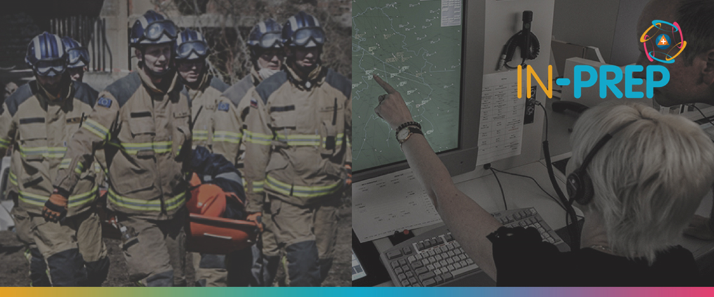
Document Summary Information

Grant Agreement No | 740627 | Acronym | IN-PREP
Full Title | An Integrated next generation preparedness programme for improving effective interorganisational response capacity in complex environments of disasters and causes of crises
Start Date | 01/09/ 2017 | Duration | 36 months
Project URL | https://www.in-prep.eu
Deliverable | D2.2, Legal, ethical and privacy impact assessment report
Work Package | Wp2 - User Needs and Ethical, Legal and Human Factors in System Development
Contractual due date | 30/06/2018 (M10) | Actual submission date |  | 30/06/2018
Nature | Report | Dissemination Level |  | CO (Confidential)
Lead Beneficiary | TRI
Responsible Author | Katrina Petersen (TRI), Katerina Poliou (TRI)
Contributions from | DhPol, DXT, ICCS, CPLAN

Executive Summary
This document is the preliminary output from the ethical and privacy impact assessment in WP2 (User Needs and Ethical, Legal and Human Factors in System Development). It sets out a comprehensive report of the ethical, privacy, legal and social impact assessment process (E/PIA) conducted for the IN-PREP project, and its initial findings. This document is for internal use within the consortium (and towards the EC/REA) and is primarily intended to assist the consortium partners in the development and delivery of a system that meets privacy, ethical, legal, and social requirements.
The introduction sets out the necessity of an Ethical and Privacy Impact Assessment (E/PIA) in the context of IN-PREP. Chapter Two of the report includes an overview of the E/PIA scope and methodology, including concept of the E/PIA, its alignment with the IN-PREP project management approach. Chapter three describes the methodology of the E/PIA process, including its engagement with IN-PREP’s requirements generation process, information flow mapping with technology partner interviews, and the project's end-user E/PIA workshop. Chapter four sets out the key findings from the exercise, primarily in terms of identified risks from different aspects of the project. Chapter five then sets out potential solutions to the privacy, ethical and social issues raised, at the level of conceptual solutions (general approaches that should be followed in the IN-PREP project) and in terms of specific adjustments to existing requirements and specific privacy and ethical requirements produced during the E/PIA process.
Copyright message
©IN-PREP Consortium, 2017-2020. This deliverable contains original unpublished work except where clearly indicated otherwise. Acknowledgement of previously published material and of the work of others has been made through appropriate citation, quotation or both. Reproduction is authorised provided the source is acknowledged.

